Moon Pad - IMC Strategy Abstract

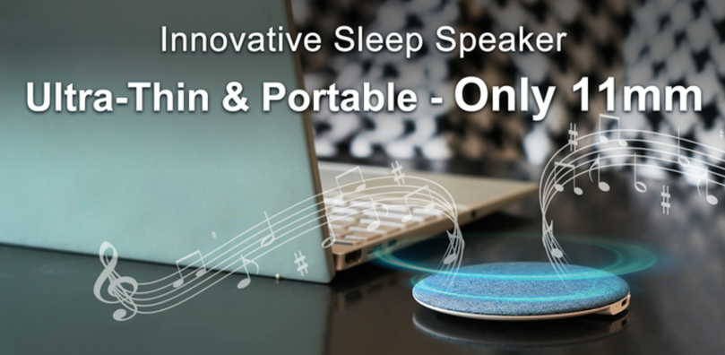
Group 1
714 Words
BMKT011
Assessment 2 – Part 1
Marketing Communication Strategy - GROUP Abstract
Content
1 Background 2
2 New Product Name 2
3 Consumer Problems Our New Product Solves 2
4 Industry Analysis 3
4.1 Industry Size 3
4.2 Industry Growth Trends 4
4.3 Demand Determinants 4
5 Customer Value Proposition 6
5.1 CVP Summary 6
5.2 Four Strategies 6
5.3 Five Categories 6
6 SMART Objective 7
References 8
Appendix 9

1 Background
Sony Corporation, founded in 1946 in Tokyo, is a global leader in electronics and entertainment. Co-founders Masao Ibuka and Akio Morita started the company by making high-quality electronic products. In the 20th century, Sony created innovative items like the Walkman, which transformed lifestyles and advanced technology.
Under the leadership of CEO Kenichiro Yoshida, Sony has focused on digital transformation and demonstrated strong financial health in FY2024, with net income of $7.3 billion, supporting R&D and market expansion (SGC, 2024). Sony’s success relies on its commitment to quality and understanding of consumer needs. Today, Sony leads in wireless headsets, gaming and entertainment.

2 New Product Name
New product name is Moon Pad.

3 Consumer Problems Our New Product Solves
Sleeping Comfort: Traditional headphones or speakers can cause discomfort while sleeping, especially for side sleepers. The Moon Pad's 11mm design ensures comfort while sleeping, while providing a high-quality audio experience.
Sound Quality Issues: Many sleep aids provide sound quality that is not clear enough to aid in relaxation. Moon Pad provides clear, high-fidelity sound through its patented acoustic design, which creates a soothing environment.
Portability and Design: Consumers want a sleep aid that is both portable and well-designed. The Moon Pad's ultra-thin design makes it easy to carry for travelling.

Battery Life: Consumers want a device that doesn't need to be recharged as often, and Moon Pad offers up to 28 hours of battery life, which reduces the frequency of recharging.
Compatibility and Ease of Use: Consumers want a device that is easy to set up and use. Moon Pad is compatible with a wide range of operating systems, including Android, etc.

4 Industry Analysis

4.1 Industry Size
The market size of the sleep technology industry in Australia is shown in the image below (Patil, 2024).
Figure 1
Industry Size

(Source: Patil, 2024)
Among them, devices such as headphones generated a total revenue of $1.7 billion in 2023 (IBISWorld, 2025a).

4.2 Industry Growth Trends
As seen in Figure 2 (Patil, 2024), the Australia sleep tech market is expected to grow.
Figure 2
Industry Growth Trends

(Source: Patil, 2024)
However, due to the fluctuations of the AUD, international trade has been volatile, affecting the stability of the export market (IBISWorld, 2025b).

4.3 Demand Determinants
The increasing prevalence of sleep disorders, affecting 15% of the adult population, is a primary driver, with inadequate sleep costing the economy over AUD 66 billion (Ellender et al., 2024). As the following picture shows (ABS, 2024), the growing aging population is more prone to sleep disorders, further amplifying demand.
Figure 3

The Number of Elderly Population

(Source: ABS, 2024)
Benefiting from COVID-19, the rise of working from home, consumer awareness of the importance of sleep health is rising (IBISWorld, 2025a). Moreover, as Figure 4 shows (Ellender et al., 2024), subjective sleep monitoring tools like sleep diaries overestimate sleep duration and underestimate wakefulness.
Figure 4
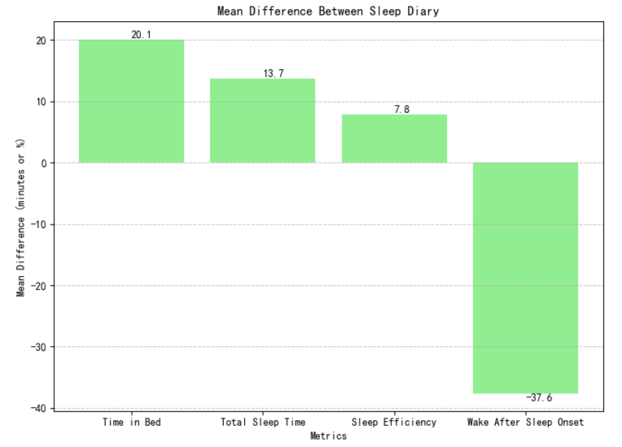
Mean Difference Between Sleep Diary
(Source: Ellender et al., 2024)

5 Customer Value Proposition

5.1 CVP Summary
Moon Pad solves the pain points of traditional sleep audio devices for consumers who pursue comfortable sleep, high-quality audio, and portability, and bring them a super-value experience.

5.2 Four Strategies
Emphasise the Benefits: The Moon Pad features ultra-long battery life, ensuring long-term usage, addressing issues of traditional sleep audio devices.
Emphasize the Favourable Differences: The product’s excellent bass and treble performance make it stand out among many ordinary sleep speakers.
Emphasize the Critical Value Factors: The excellent sound quality brought by the patented acoustic design can immerse users in the audio world.
Emphasize the Threshold Removers: The Moon Pad offers early-bird discounts, reducing the purchase cost for consumers.

5.3 Five Categories
Functional Value: Specifically designed for sleep optimization with built-in pillow speakers.
Emotional Value: The sense of relaxation and peace of mind this product provides.
Economic Value: The early-bird discount price of this product is appealing.
Symbolic Value: Sony, with over a decade of pro audio experience, uses advanced tech and innovative design in its products.

End Value: The product conveys the lifestyle concept of health, comfort, and convenience, enabling users to have a better mental state and realise the ultimate goal of pursuing a comfortable life.

6 SMART Objective
Objective is to enhance brand awareness and achieve a 25% increase in market penetration within the next 12 months.

References
Australian Bureau of Statistics (ABS). (2024). Population Ageing in Australia. https://www.abs.gov.au/statistics/people/population/population-clock-pyramid
Ellender, C. M., Ruehland, W. R., Duce, B., Joyce, R., Worsnop, C., Mercer, J., Naughton, M., Hukins, C. A., Wheatley, J., & Cunnington, D. (2024). Australasian Sleep Association 2024 guidelines for sleep studies in adults. Sleep, 47(10), 107. https://doi.org/10.1093/sleep/zsae107
IBISWorld. (2025a). C2429 Audio Visual Electronic Equipment Manufacturing in Australia Industry Report. https://my-ibisworld-com.ezproxy.lib.uts.edu.au/au/en/industry/C2429/products-and-markets
IBISWorld. (2025b). C2429 Audio Visual Electronic Equipment Manufacturing in Australia Risk Ratings Report. https://my-ibisworld-com.ezproxy.lib.uts.edu.au/download/au/en/risk-rating/267/1/0/pdf
Patil, C. (2024). Australia Sleep Tech Market Size, Share & Trends Analysis Report By Product Type (Wearable Devices, Non-Wearable Devices, Sleep Aids), By Application (Sleep Monitoring and Management, Sleep Diagnostics, Therapeutic Use), By Distribution Channel (Online Retail, Offline Retail), By End-User (Residential, Commercial) and Forecasts, 2024-2032. https://straitsresearch.com/report/sleep-tech-market/australia
Sony Group Corporation (SGC). (2024). CORPORATE REPORT 2024. https://www.sony.com/en/SonyInfo/IR/library/corporatereport/CorporateReport2024/read/

Appendix
Student Name | Student ID | Section # | Personal Contribution % | Number of Comments
Ziyu Chen | 23124312 | 1 | 13% | 19
Bowen Hu | 23124335 | 2 | 17% | 21
Yuanhao Zhu | 23124311 | 3 | 17% | 30
Yan Xu | 23124326 | 5 | 17% | 25
Jiashang Cao | 23124343 | 6 & 7 & 8 | 19% | 30
Yan Chen | 23124313 | 4 | 17% | 21

